- AQ1
SELECT Location_Name,Time_Year,Time_Month,SUM(Quantity_Ordered*Unit_Price) AS AMT,SUM(SUM(Quantity_Ordered*Unit_Price)) OVER (Partition by Location_Name,Time_Year Order By Time_Month ROWS UNBOUNDED PRECEDING) AS CUMSUMAMT

FROM W_JOB_F,W_LOCATION_D,W_TIME_D

WHERE W_JOB_F.Location_ID = W_LOCATION_D.Location_ID AND W_TIME_D.Time_id = W_JOB_F.Contract_date

GROUP BY Location_Name,Time_Year,Time_Month;

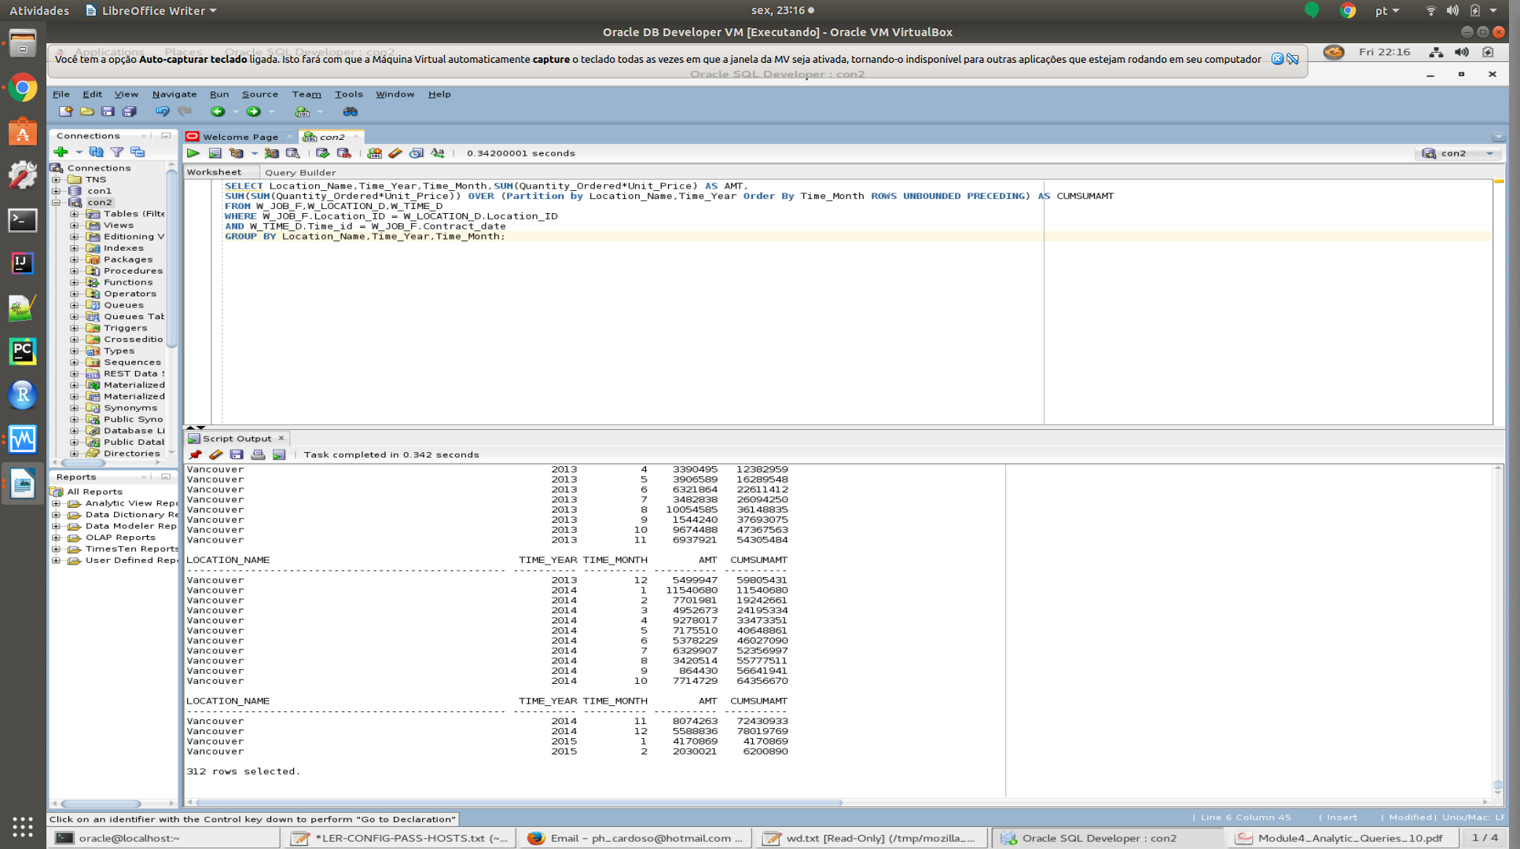

- AQ2
SELECT X1.Location_Name, X1.Time_Year,
SUM(SumInvoiceAmt - TotalCosts) AS SumLocProfit,
RANK() OVER ( PARTITION BY X1.Time_Year
ORDER BY ( SUM(SumInvoiceAmt - TotalCosts) ) DESC ) AS RankProfitSum
FROM BQ2 X1, BQ3 X2
WHERE X1.Job_Id = X2.Job_Id
GROUP BY X1.Location_Name, X1.Time_Year;
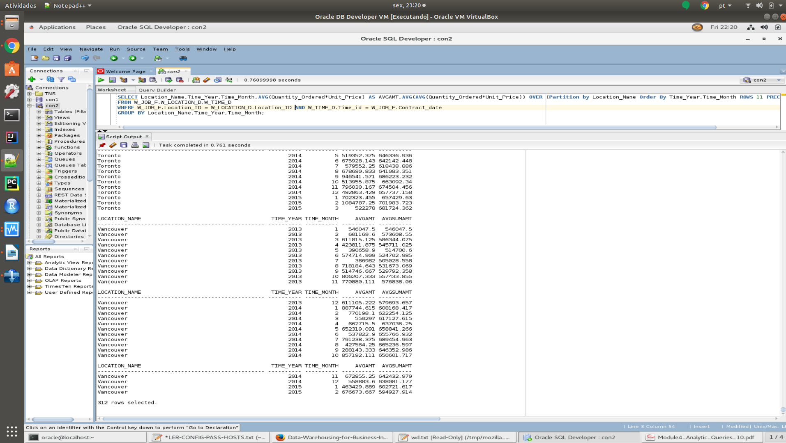

- AQ3
SELECT Location_Name, Time_Year, Time_Month, AVG(Quantity_Ordered*Unit_Price) AS AVGAMT, AVG(AVG(Quantity_Ordered*Unit_Price)) OVER (Partition by Location_Name Order By Time_Year, Time_Month ROWS 11 PRECEDING) AS AVGSUMAMT

FROM W_JOB_F, W_LOCATION_D, W_TIME_D

WHERE W_JOB_F.Location_ID = W_LOCATION_D.Location_ID AND W_TIME_D.Time_id = W_JOB_F.Contract_date

GROUP BY Location_Name, Time_Year, Time_Month;

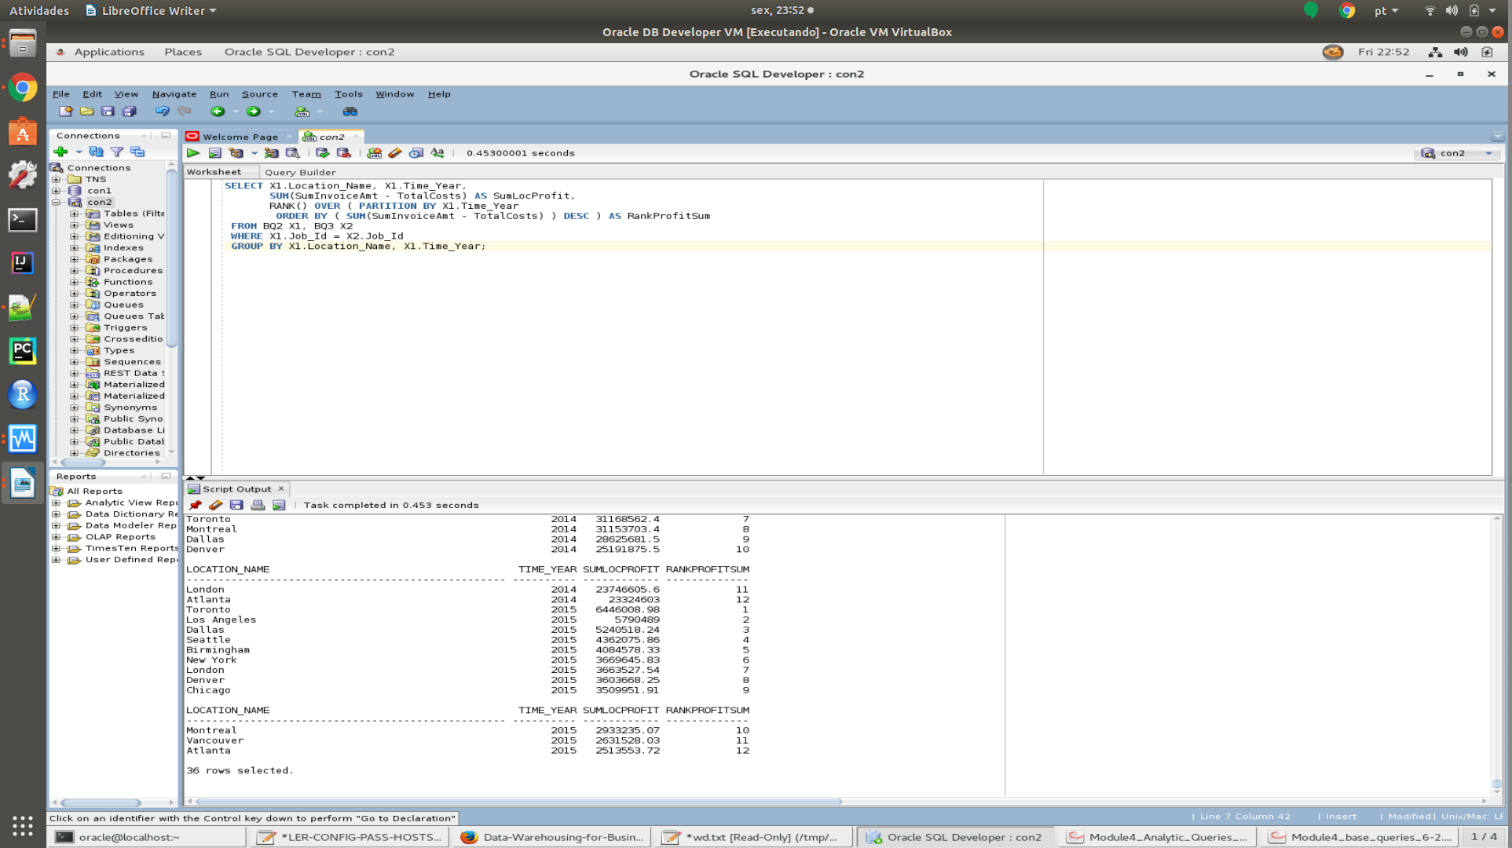
- AQ4
SELECT BQ2.Location_Name, BQ2.Time_Year, BQ2.Time_Month, SUM(SUMINVAMT - TOTALCOST)/SUM(SUMINVAMT) AS ProfitMargin, RANK() OVER(Partition By BQ2.Time_Year Order by SUM(SUMINVAMT - TOTALCOST)/SUM(SUMINVAMT) DESC) AS Rank

FROM BQ2, BQ3

WHERE BQ2.Job_id = BQ3.Job_id

GROUP BY BQ2.Location_Name, BQ2.Time_Year, BQ2.Time_Month;

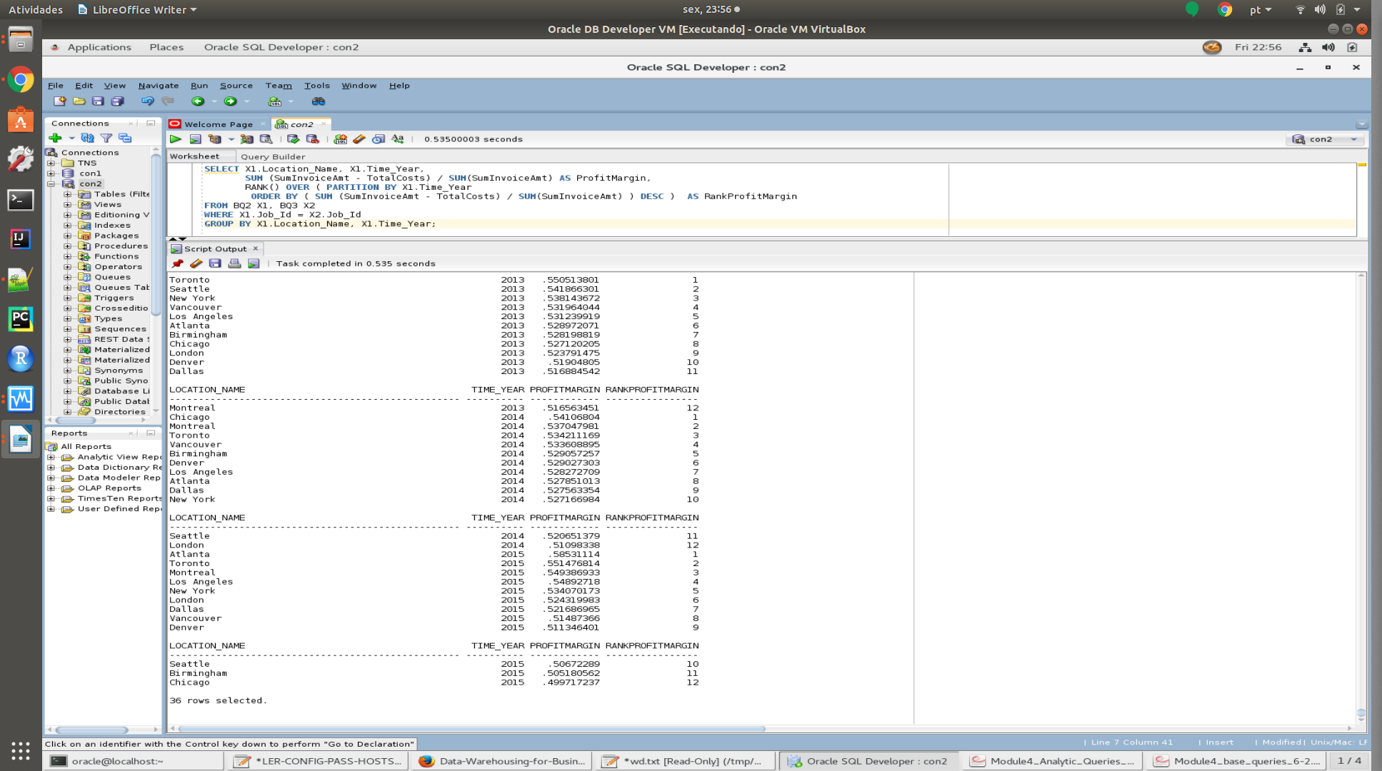

- AQ5
SELECT X1.Job_Id, X1.Location_Name, X1.Time_Year, X1.Time_Year, (SumInvoiceAmt - TotalCosts) / SumInvoiceAmt AS ProfitMargin, PERCENT_RANK() OVER ( ORDER BY ( (SumInvoiceAmt - TotalCosts) / SumInvoiceAmt ) ) AS PercentRankProfitMargin

FROM BQ2 X1, BQ3 X2

WHERE X1.Job_Id = X2.Job_Id;

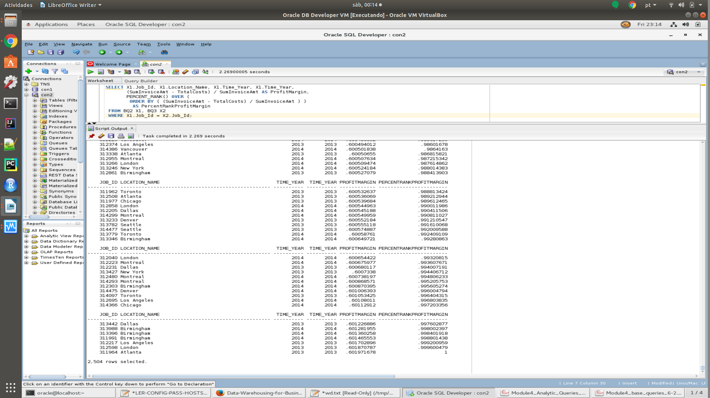

- AQ6
SELECT Job_Id, Location_Name, Time_Year, Time_Month, ProfitMargin, PercentRankProfitMargin

FROM (SELECT X1.Job_Id, X1.Location_Name, X1.Time_Year, X1.Time_Month, (SumInvoiceAmt - TotalCosts) / SumInvoiceAmt AS ProfitMargin,PERCENT_RANK() OVER ( ORDER BY ( (SumInvoiceAmt - TotalCosts) / SumInvoiceAmt ) ) AS PercentRankProfitMargin

FROM BQ2 X1, BQ3 X2

WHERE X1.Job_Id = X2.Job_Id )

WHERE PercentRankProfitMargin > 0.95;
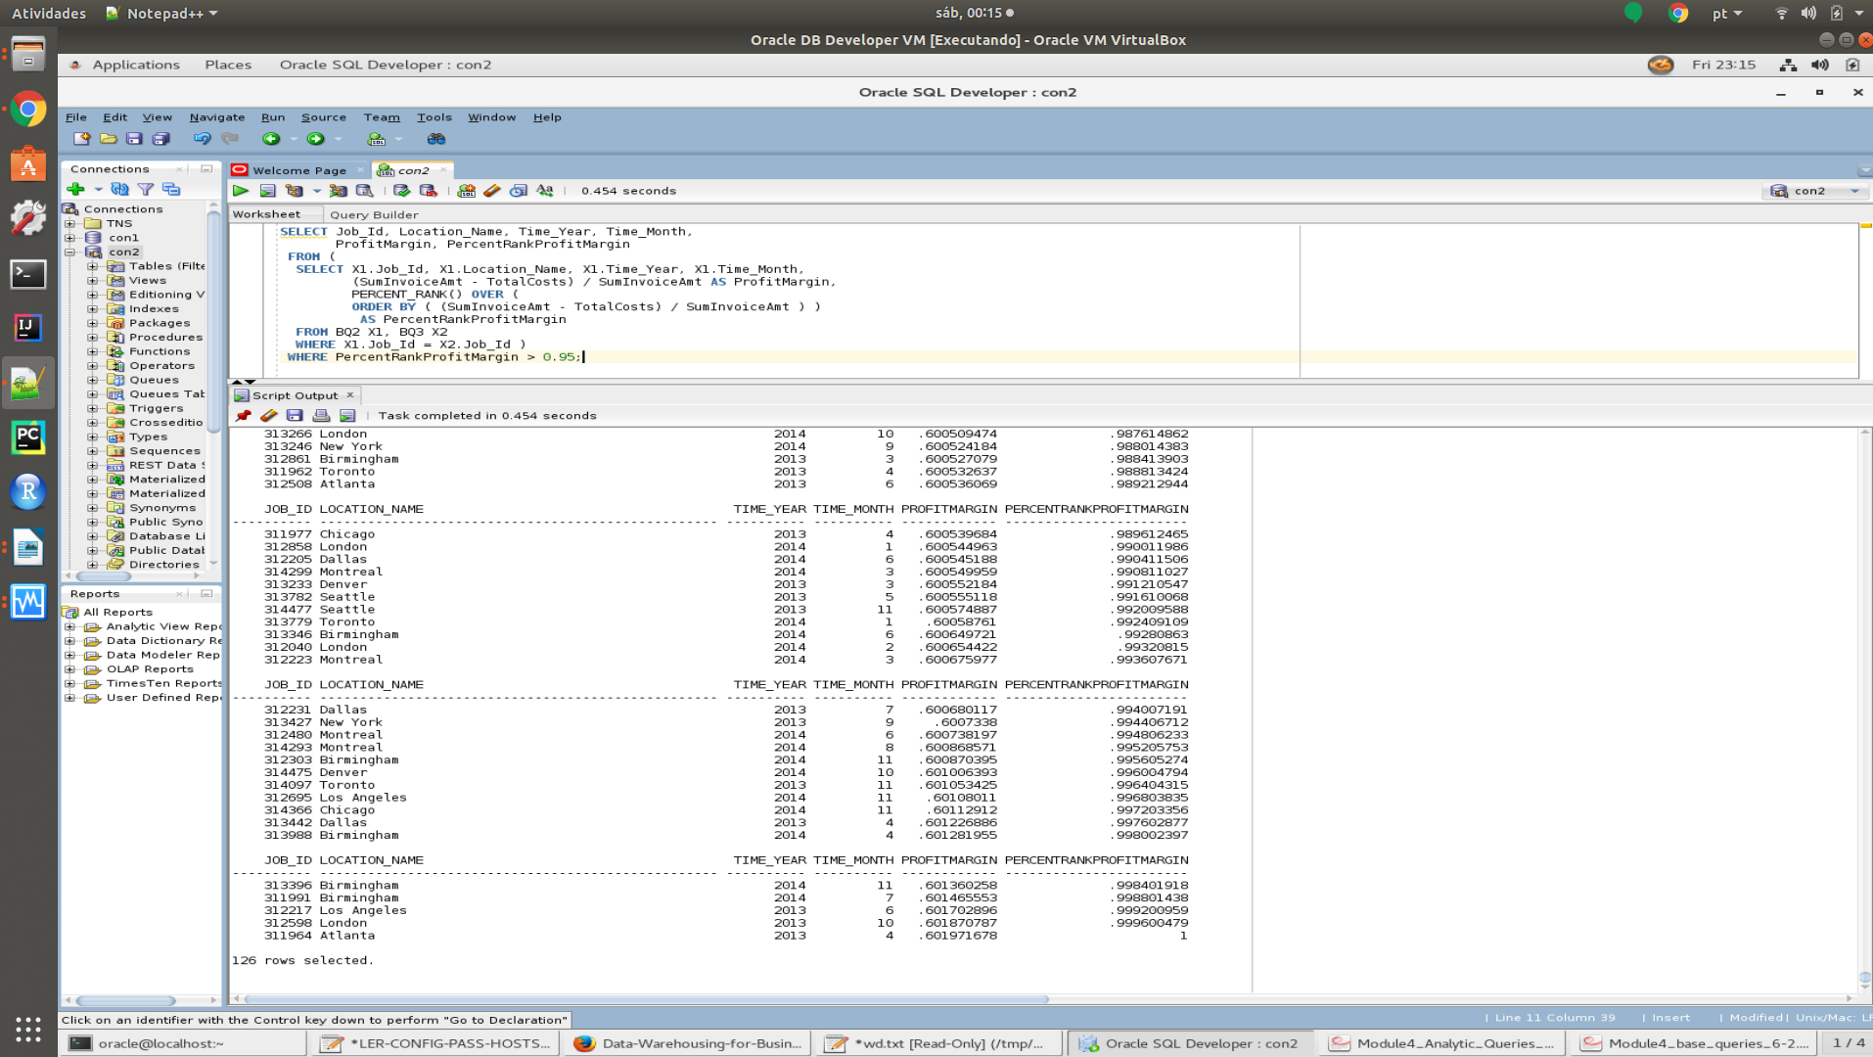
- AQ7
SELECT Sales_Class_Desc, Time_Year, SUM ( quantity_shipped - invoice_quantity ) as ReturnSum , RANK() over ( PARTITION BY Time_Year

ORDER BY SUM ( quantity_shipped - invoice_quantity ) DESC ) AS RankReturnSum

FROM W_INVOICELINE_F INNER JOIN W_TIME_D
ON W_INVOICELINE_F.INVOICE_SENT_DATE = W_TIME_D.TIME_ID

INNER JOIN W_Sales_Class_D
ON W_INVOICELINE_F.Sales_Class_Id = W_Sales_Class_D.Sales_Class_Id

WHERE quantity_shipped > invoice_quantity

GROUP BY Sales_Class_Desc, Time_Year;

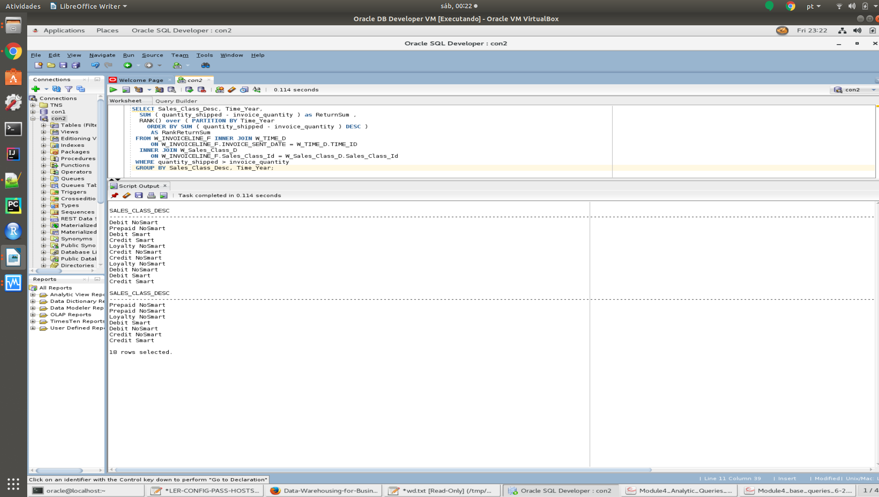

- AQ8
SELECT Time_Year, Sales_Class_Desc, SUM ( quantity_shipped - invoice_quantity ) as SumReturnQty, Ratio_To_Report(SUM ( quantity_shipped - invoice_quantity ))
OVER ( PARTITION BY Time_Year ) AS RatioReturnSum

FROM W_INVOICELINE_F INNER JOIN W_TIME_D
ON W_INVOICELINE_F.INVOICE_SENT_DATE = W_TIME_D.TIME_ID

INNER JOIN W_Sales_Class_D
ON W_INVOICELINE_F.Sales_Class_Id = W_Sales_Class_D.Sales_Class_Id

WHERE quantity_shipped > invoice_quantity

GROUP BY Sales_Class_Desc, Time_Year

ORDER BY Time_Year, SUM( quantity_shipped - invoice_quantity );

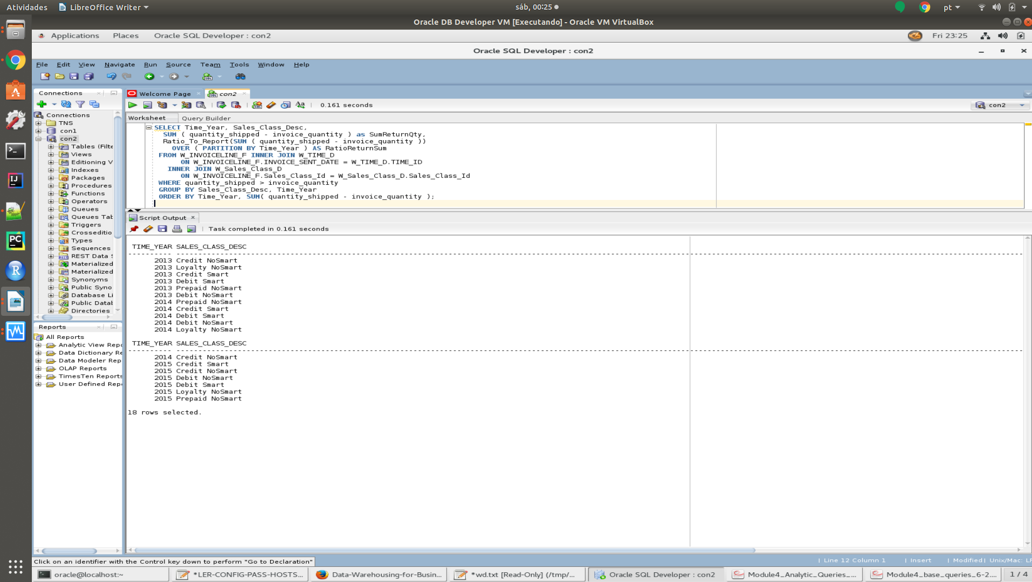

- AQ9
SELECT Location_Name, W_Time_D.Time_Year, SUM(BusDaysDiff) as SumDelayDays, RANK() OVER ( PARTITION BY W_Time_D.Time_Year
ORDER BY SUM(BusDaysDiff) DESC) AS RankSumDelayDays, DENSE_RANK() OVER ( PARTITION BY W_Time_D.Time_Year ORDER BY SUM(BusDaysDiff) DESC) AS RankSumDelayDays

FROM BQ6, W_Time_D

WHERE W_Time_D.Time_Id = BQ6.Date_Ship_By

GROUP BY Location_Name, W_Time_D.Time_Year;

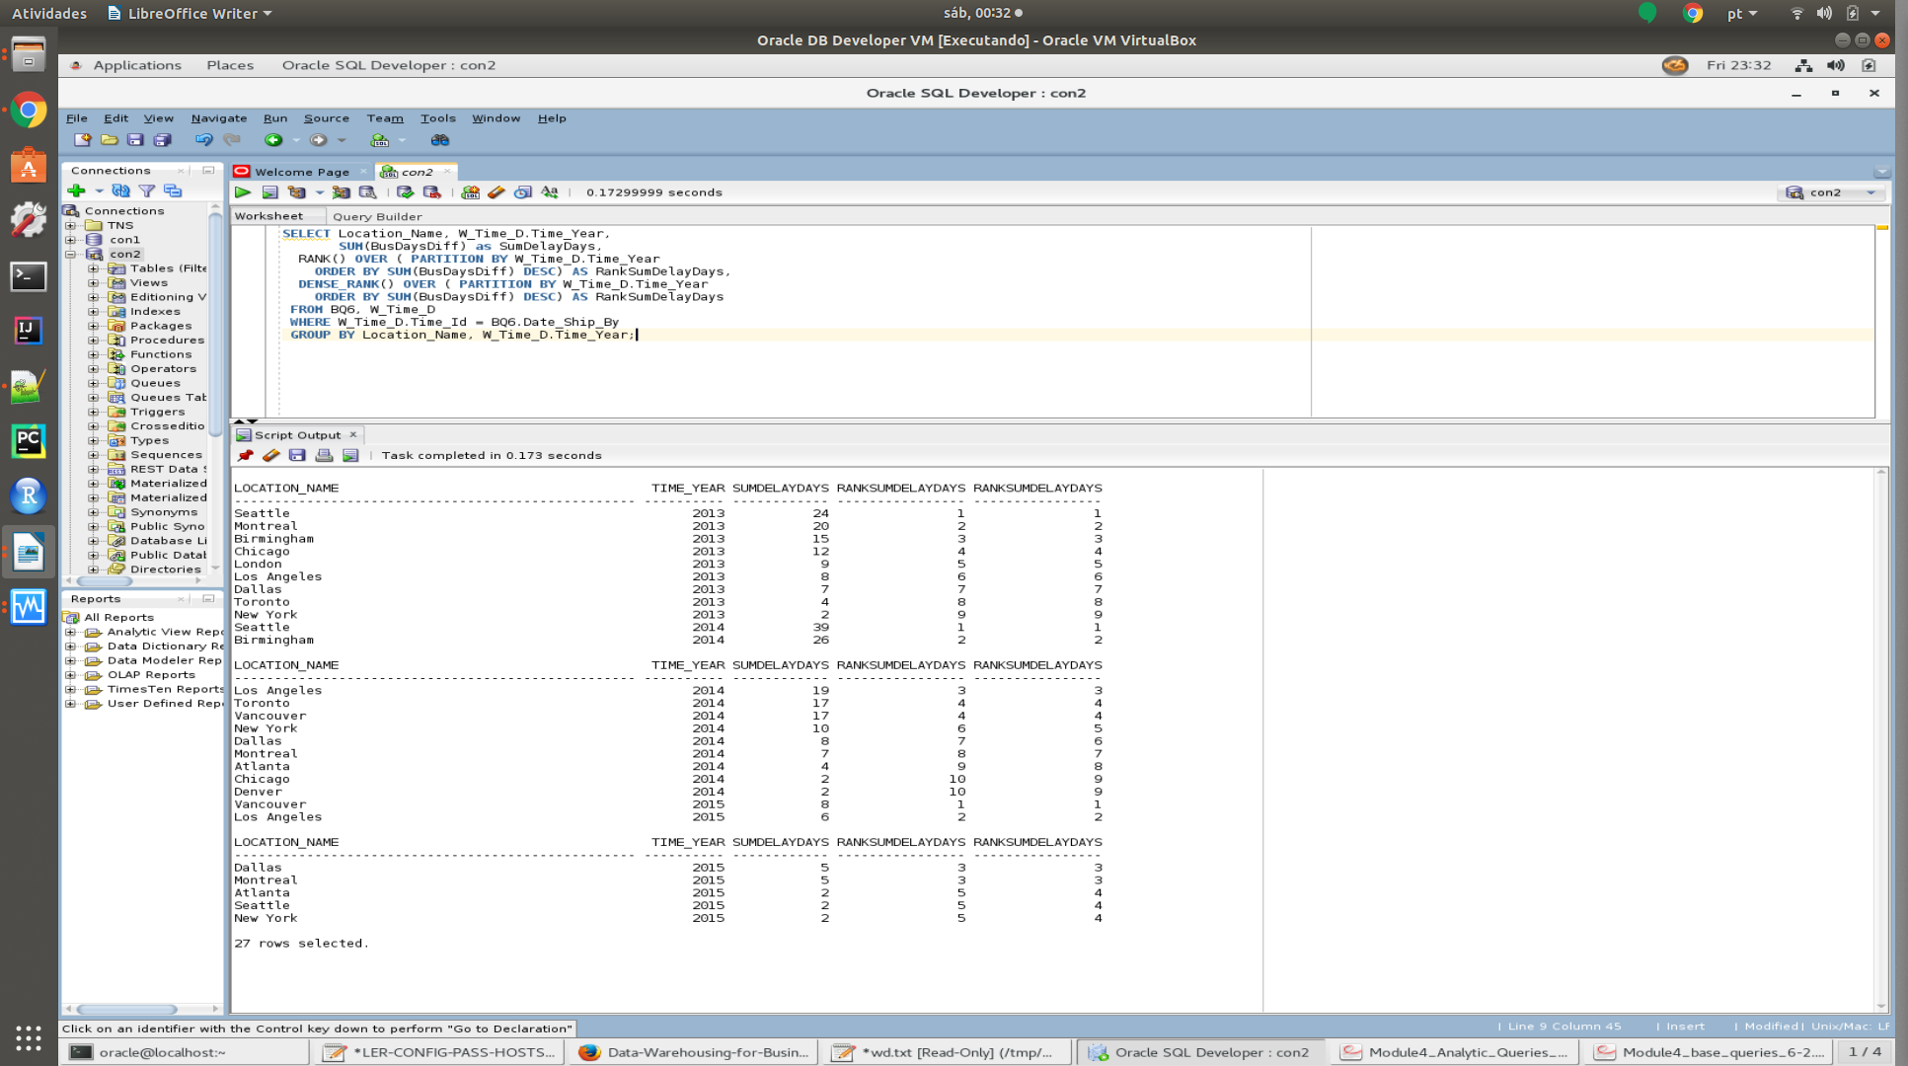
- BQ10
SELECT Location_Name, W_Time_D.Time_Year, COUNT(*) AS NumJobs, SUM(BusDaysDiff) as SumDelayDays, SUM(Quantity_Ordered - SumDelayShipQty) / SUM(Quantity_Ordered) AS PromisedDelayRate, RANK() OVER ( PARTITION BY W_Time_D.Time_Year
ORDER BY SUM(Quantity_Ordered - SumDelayShipQty)/SUM(Quantity_Ordered) DESC) AS RankDelayRate

FROM BQ5, W_Time_D

WHERE W_Time_D.Time_Id = BQ5.Date_Promised

GROUP BY Location_Name, W_Time_D.Time_Year;



